Abstract template for THE conference OVZDUŠÍ V ČASE

John SMITH¹, Petr PLAMÍNEK^{1,2}, Jaroslav WEIS²

¹ First Institute, AS CR, Prague, Czech Republic, email@institute.cz
² Second Institute, City, Country, email@network.com

Keywords: Atmospheric aerosols, Chemical composition, AMS, PM1

INTRODUCTION

The abstract should be in one column (like this example) with lenght 1-4 pages. Use A4 page set-up and make following format: top and bottom margin 2.5 cm (0.98 inch), inside margin 3 cm (1.18 inch) and outside margin 2 cm (0.79 inch). Set a portrait orintation, mirro margins and single line spacing (Fig. 1).

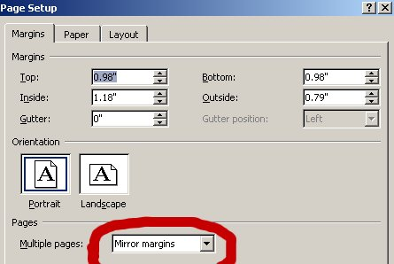
Fig. 1: Page setup in Word

METHODOLOGY

Use 12 pt Cambria font. The title is in bold capital letters and centered. Centered text is also used for authors' names, addresses, keywords, and headings, which should be roughly as follows: Introduction, Methodology, Results and Discussion, Conclusions, Acknowledgments, and References.

RESULTS, DISCUSSION, CONCLUSIONS

Each paragraph begins with an indent and the text is aligned to the block.

Only horizontal lines are used in tables (see Table 2).

Tab. 2: Table example
 | Dresden | Augsburg | Prague | Ljubljana | Chernivtsi
Aerosol flow | 1 lpm | 0.5 lpm | 1 lpm | 1 lpm | 1 lpm
A. temperature | 10-30 °C |  | 10 – 30 °C | 10-30 °C | 10-30 °C

It is better to insert graphs as pictures (e.g., jpg, png) rather than directly from Excel to prevent text from becoming "scattered." For the same reason, it is better to export diagrams as pictures rather than drawing them directly in Word. The font in graphs should be large enough to make the text easily readable. The proceedings will be printed in A5 format.

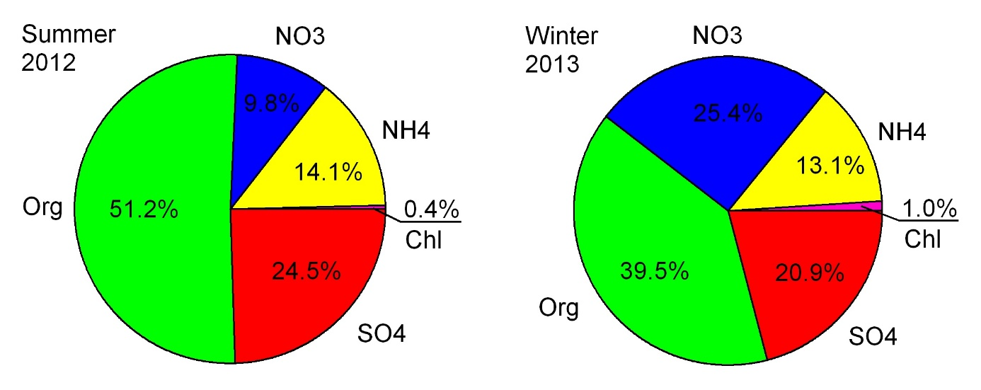Fig. 2: An example of figure - an average relative composition of non-refractory aerosol

An examle of an equation is here.

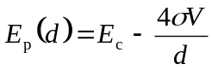, (1)

References should be made in the style (Paatero, 1999), Brunekreef - Holgate (2002) or as Liu et al. (1997). Examples of references are shown below.

ACKNOWLEDGEMENT

This work was supported by the Czech Science Foundation under grant P209/11/1342 etc.

REFERENCES

Brunekreef B., Holgate S. T., Air pollution and health, Lancet, 360, 1233-1243, (2002).

Liu, D., Rutherford, D., Kinsey, M., Prather, K., Real-time monitoring of pyrotechnically derived aerosol particles in the troposphere, Anal. Chem., 69, 1808-1814, (1997).

Paatero, P. The multilinear engine – a table-driven least squares program for solving multilinear problems, including the n-way parallel factor analysis model. J Comput Graph Stat. 1999;8:854–888.

Please send the file named Surename_Abstract_OvC2026 in .docx format so that it can be further edited.

